# Setting up Excel Template

## 01- Trust the File for Macros to Work

### 1.1- Right Click the Template "Book.Xltm"

### 1.2- You'll See Under General on the Bottom:

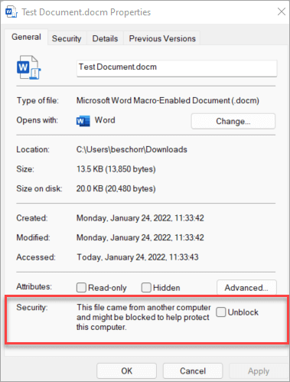

Security: This file came from another computer etc..

And a Checkbox for Unblock

Check that Checkbox and click OK

### 1.3- Open the Template to Test

Make sure the Macros and shortcuts and the custom table styles are all working in that file.

## 02- Put the Template in You Excel's Startup Folder

To get the startup folder path do the following

### 2.1- Open An Excel File

### 2.2- Open the Developer Tab

If you don't see it then customize the Ribbon and select it to show

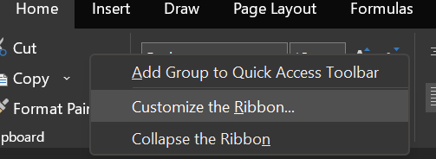

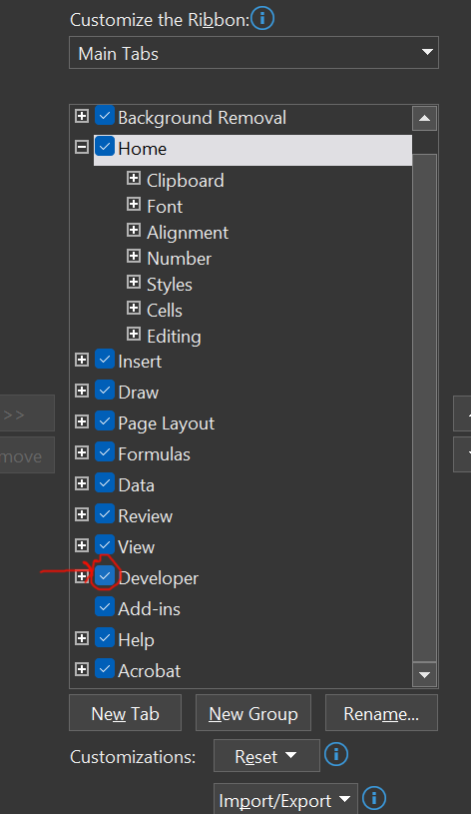

### 2.3- Open Visual Basic

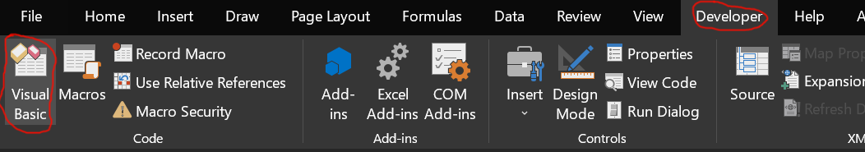

### 2.4- If You Don't See the "Immediate Window" Do the Following

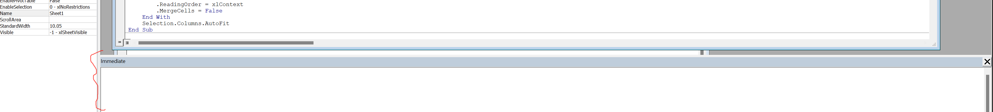

You can press Ctrl + G to show it

If it doesn't show up go the "View" tab and click on "Immediate Window"

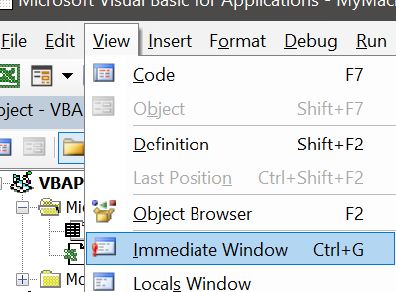

### 2.5- Enter the Following Command in the Immediate Window

? application.StartupPath

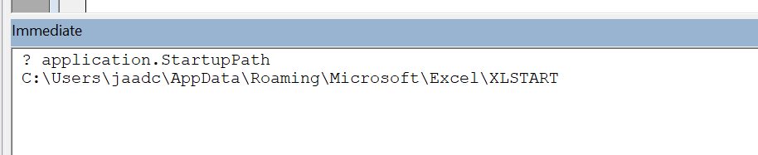

### 2.6- The Excel Startup Path Should Now Show

The current one for me is C:\Users\jaadc\AppData\Roaming\Microsoft\Excel\XLSTART

### 2.7- Go to That Path and Paste the Template There

Open New Excel using shortcut “Ctrl + Alt + X” and test the macros + keyboard shortcut.

### 2.8- What We Have Now

Now the macros and shortcuts work

But the table custom style doesn't work

We will fix that with the next step

## 03- Put the Templates in Your Excel's Template Folder

We need to do this so we can use the custom table styles.

### 3.1- Open New Excel File and Go to Options

Click the File Tab

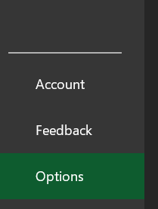

### 3.2- Get the Path Where Templates are Stored

Go to the Save Tab of Options

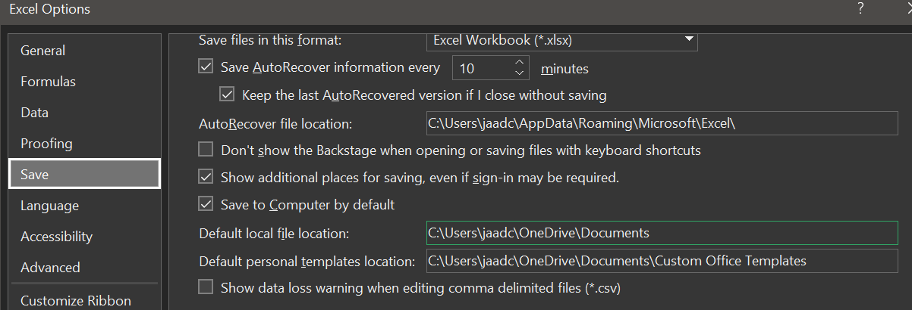

The Path here is C:\Users\jaadc\OneDrive\Documents\Custom Office Templates

### 3.3- Put the Template at That Path

### 3.4- Pin the Temple on the Excel Startup Page

Now every time you open excel, you should open the template for the styles to show up

To make it easier we will pin the template on the Excel startup page

Click on “More templates”

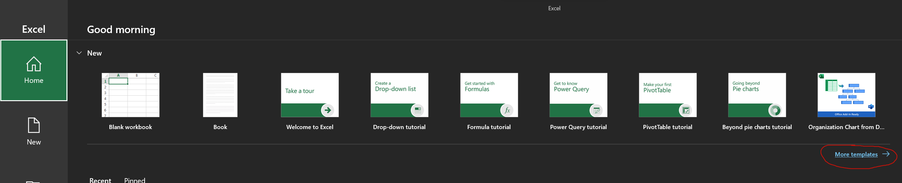

Click on the “Personal” Tab and Pin the Template “Book”

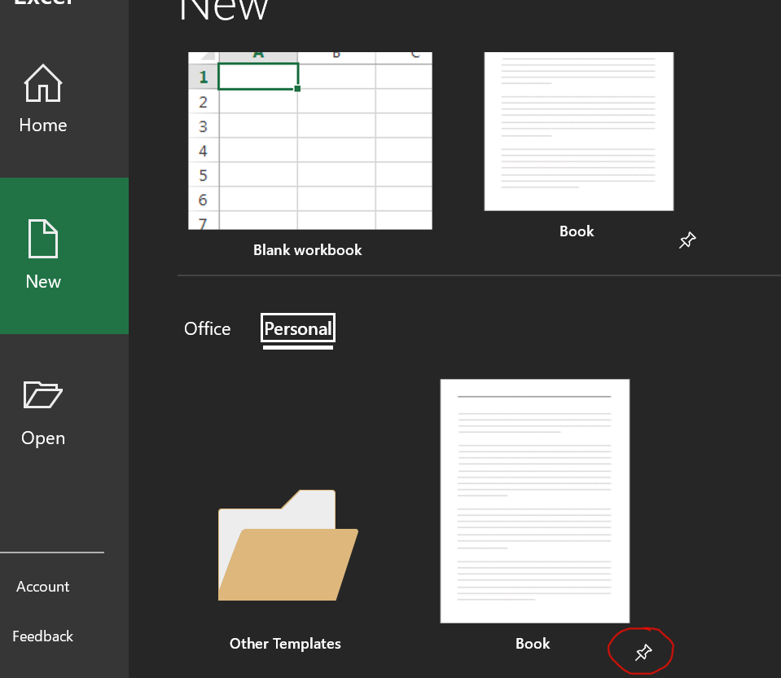

Now you see it pinned.

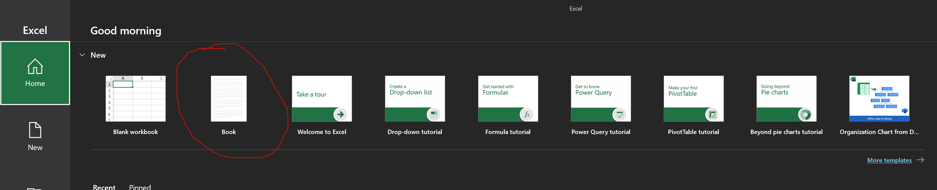

### 3.5- From Now on Click the Temple Instead of “Blank Workbook”

This is the simplest way to get the Custom Styles to work.

If we create new Custom Styles, make sure to save as template and override the current template at that same path.

## 04- How to Create a New Custom Table Style

You want to make sure to open your current template, and after finishing to save as that template (with the same name) and replace it.

If you want it to be a separate template then save it in the same folder with a different name and you can pin that as well.

### 4.1- Create a Table

The easiest way to get to the Styles is creating a Table.

Highlight any cells and press Ctrl + T to create a table.

Highlight that table.

Now you have the “Table Design” Tabs

You can right click any style and Duplicate it.

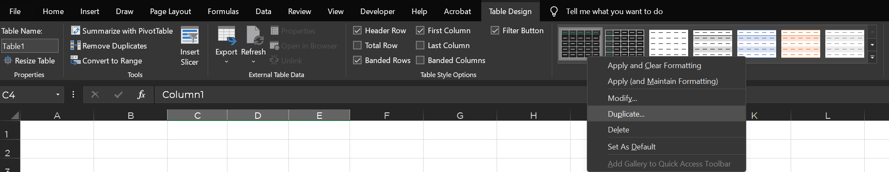

Then you can right click that and select “Modify”

You can rename and change a bunch of things in it that I won’t get into now

To edit each one of the “Table Elements” you highlight it and choose “Format” etc..

